Mellon Mays and Bouchet Fellows: Class of 2021

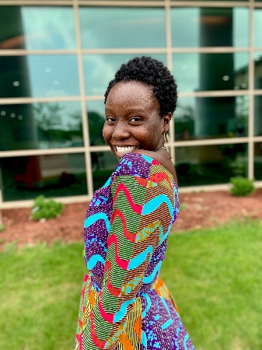
Rebecca Amonor
Mellon Mays Fellow
Rebecca Amonor is an English and African American studies double major in Timothy Dwight college. A child of Ghanaian immigrants, Rebecca is interested in studying the unique position of second generation African Americans in literature. She hopes to explore the topics of belonging, community and representation, opening up the larger conversation of intersectionality in the African American identity.

Gabriella Blatt
Mellon Mays Fellow
Gabriella Blatt is an Ethnicity, Race, and Migration major in Ezra Stiles College. She is a member of the Chippewa Cree tribe from Rocky Boy Montana. Her research interests include eco-criticism and Indigenous literature, in which her main focus has been on contemporary Native American literature and it’s meanings within the Anthropocene. She hopes to show how Indigenous authors offer ways out of the “crisis of imagination” when thinking about the climate crisis and give visibility to climate change’s problems and solutions.

Meghanlata Gupta
Bouchet Fellow
Meghanlata Gupta is a junior in Morse College and a member of the Sault Ste. Marie Tribe of Chippewa Indians. Majoring in Ethnicity, Race, and Migration, Meghan's research focuses on tradition as a healing mechanism, Anishinaabe ways of health and medicine, and Indigenous reconciliation in the classroom. Her project centers around an analysis of culture-based substance abuse prevention programs that her tribe provides. Through her project, Meghan hopes to argue for the necessity of indigenizing methodologies in health and educational spaces.

Alejandro Nuno
Bouchet Fellow
Alejandro Nuno is a Molecular, Cellular, and Developmental Biology major (Neurobiology Track) in Grace Hopper College. His research focuses on a subset of cells in the visual cortex, Vasoactive Intestinal Peptide Interneurons (VIP-INs), that make up 1% of all brain cells. These cells are recognized by the field as critical during neurodevelopment and associated with certain neurodevelopmental disorders such as schizophrenia and autism. His work focuses on understanding how these cells are critical to neurodevelopment and how they affect the plasticity of the brain, the ability of the brain to bridge the gap between old and new, relative experiences. He hopes to continue his work in neuroscience by pursuing an M.D./Ph.D or a Ph.D in neuroscience after finishing his undergraduate studies.
Victoria Quintanilla
Mellon Mays Fellow
Victoria Isabel Quintanilla is a History and East Asian Studies double major in Berkeley College. She is interested in Otherness and Otherization in the Korean peninsula. Her research focuses on the effects of the economy on understandings of Koreanness. Through a historical lens, her work aims to comprehend how contemporary notions of Koreanhood have formed and been informed, especially as the Republic of Korea’s borders continue to open and globalize.

Brian Reyes
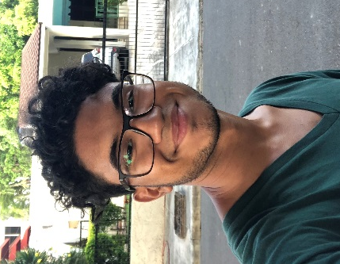
Mellon Mays Fellow
Brian Reyes is a junior in Berkeley College majoring in History. His broad interest is the intersection of race and capitalism, and his research focuses specifically on the history of Black and Latinx entrepreneurship and corporations in the United States. Through this focus, he seeks to understand entrepreneurship as a survival strategy, problematize conceptions of racial inequality that focus on the individual rather than societal structures, and interrogate the possibilities of achieving racial justice through capitalistic economic "empowerment".

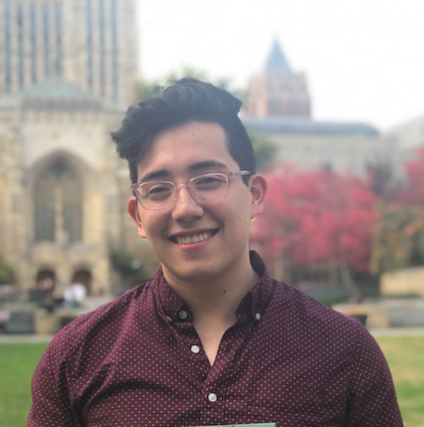
Henry Rosas Ibarra
Mellon Mays Fellow
Henry Rosas is an Ethnicity, Race, and Migration major and a junior in Timothy Dwight College. Born and raised in Phoenix, Arizona, his research focuses on how white supremacists in Arizona used legal, political, and social mechanisms to systemically target Latinx communities in Phoenix throughout the 2010s. His research hopes to better understand how this period in Arizona history altered the political consciousness and definitions of latinidad amongst Latinx organizers and political actors. Using archival and ethnographic methods, he hopes his research will provide a contemporary analysis on the state of Latinx politics that prioritizes the voices of activists and campaigns they built.

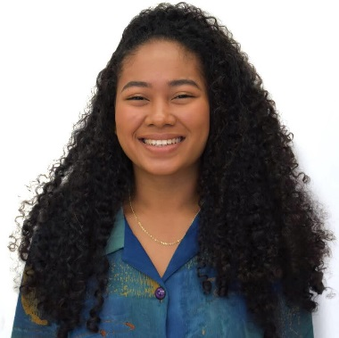
Saaya Sugiyama-Spearman
Bouchet Fellow
Saaya is a junior in Jonathan Edwards College majoring in Astrophysics. Born and raised in Philadelphia in a household speaking both Japanese and English, Saaya is learning yet another language during her time at Yale. She is learning the language that will allow her to communicate with both members and non-members of the Astronomy community worldwide about her ideas, research, and interests. Her research revolves around the phenomenon of the formation of planetary systems, much like our own solar system, containing planets of relatively equal size, all equidistant apart from each other as they revolve around their host star.

Irene Vazquez
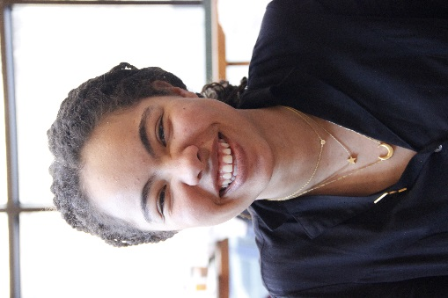
Bouchet Fellow
Irene Vázquez is an English and Ethnicity, Race, & Migration major in Berkeley College. Her research interests include the poetics of redress, witness, and belonging and Black feminist theory. Her project explores the way that the poetics of writers from Guadeloupe and Martinique can help envision non-sovereign futures for countries in the Global South. By using literature as a lens, she hopes to expand the way that political language conceives of liberation and governance outside of Western modes of thinking.

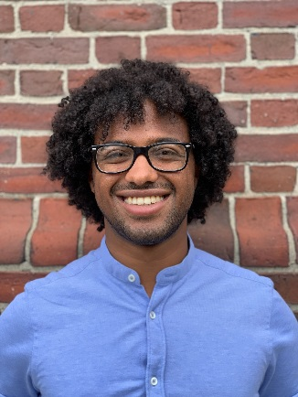
Keduse Worku
Bouchet Fellow
Keduse Worku is a junior Physics major in Pierson College, and his research is in the field of Astrophysics. His work examines why two types of exoplanets, warm and hot Jupiters, share very similar characteristics yet warm Jupiters often have companion planets and hot Jupiters do not. This work is carried out through n-body simulations under the direction of Professor Greg Laughlin and Dr. Christopher Spalding. Keduse is also continuing summer research with Dr. Grant Tremblay from the CfA at Harvard, looking at brightest cluster galaxies and the effects of black hole feedback on the overall cluster’s processes, like star formation.

